

Tri-generation System Modifications

Group 12:
Maggie Alvarado, Natalie Levings, Bruno Viera,
Raphael Cavalcanti, Diego Azevedo Richard Robards



Sponsored by Shell

Table of Contents
Table of Contents 2
I. Executive Summary/Abstract: 5
II. Introduction 6
III. Collaboration between UFPR and FSU 7
IV. Project Background 8
V. Product Specifications 12
VI. Concept Generation and Selection 13
6-5 Alternative Fuel Conceptual Designs 20
6-6 Alternative Fuel Design Selection 22
Gas Expansion 23
Conclusion 23
VII. Conclusion 25
VIII. References 26
Appendix A: System User Manual and Parts List 27
Trigeneration Prototype User’s Manual 27
Warnings and Precautions 27
Overall Operation 27
Maintenance 30
Current System Parts List 30
A-1: Absorption Refrigerator Supporting Calculations and Previous Analysis 34
A-2: Water Heating Unit Parts List and Previous Analysis 36
Appendix B: Collaboration with Brazil 38
Appendix B-1: Meeting Minutes 38
Group Meeting: 19/September/2006 38
Group Meeting: 20/September/2006 39
Staff Meeting: 21/September/2006 39
Group Meeting: 4/October/2006 40
Group Meeting: 4/October/2006 40
Staff Meeting: 5/October/2006 41
Video Conference: 25/October/2006 41
Staff Meeting: 26/October/2006 42
Group meeting: 31/October/2006 42
Video Conference: 1/November/2006 43
Telephone Conference: 8/November/2006 44
Video Conference: 15/November/2006 44
Staff Meeting: 16/November/2006 46
Video Conference: 29/November/2006 46
Meeting Summary 46
Appendix B-2: Work Breakdown Structures 47
Appendix C: Conceptual Designs Drawings and Schematics 51
Appendix C-1: Heat Bypass Design and Schematics 51
Appendix D: Supporting Calculations 56
Appendix D-1: Distiller Supporting Calculations 56
Appendix D-2: Adapted Engine Theoretical Performance Calculations 57
Appendix E: Vendors 61
Appendix F: Cost Analysis 62

I. Executive Summary/Abstract:

This paper describes the modifications that were done to improve a tri-generation system that was fabricated during the 2005/2006 school year between students at Florida State University (FSU) and Universidade Federal do Paraná (UFPR). In 2006 students from both schools built a tri-generation system that provided electricity, refrigeration, and heated water. The system was made up of four subsystems: an engine, a water heater, a refrigerator and a generator. The system uses heat from the exhaust that is normally wasted to power an absorption refrigerator and water heater. This year two teams from UFPR and FSU took the same system that was built last year and made modifications to improve the system and make it more efficient.

The tri-generation system that was built last year was a major success but it was in need of some improvement. One of the problems with the current system was that the engine only ran off of gasoline. If the tri-generation system were to be practical in the modern world it needs to be able to run off more than one fuel. One of the modifications is to allow the engine to run off alternative fuels. The modification allows the current engine to be able to run off of gasoline, compressed natural gas (CNG) and propane. A second problem with the current tri-generation system is that the heat to the absorption refrigerator is not controlled. If the temperature were to get too high some components can be seriously damaged. The second modification that will be done is control the temperature of the refrigerator by adding a bypass valve controlled by an actuator. The third problem with the current system was that the water-heating unit heated up too quickly to temperatures that were damaging to certain components. The third modification is to control this heat and divert a large portion of it to a distiller which will be added to the system. This distiller will provide fresh water. Another modification to the current system is to add another cool space. This will done by taking advantage of the cooling effect of gases as they expand from a high pressure to a lower pressure to be used by the engine. All of these modifications will be done using a budget of only $3400 between both of the schools.

II. Introduction
2-1: Objective
The objective is to improve the efficiency and versatility of the existing tri-generation system by addressing its current deficiencies and adding new components while working in conjunction with our teammates in the Federal University of Parana (UFPR).

2-2: Problem Definition
The purpose of this project is to improve and modify an existing tri-generation system that was built by students last year. The improvements are to modify the absorption refrigerator so that it can be controlled and to change the water-heating unit so that it can be maintenance-free for duration of 4 hours. The modifications are to allow the system to run on alternative fuels and to add a second cool space.

2-3: Statement of Need
In order to improve on the existing Tri-Generation design, a number of deficiencies have to be addressed. Although the group responsible for the tri-generation system last year was able to achieve significant improvements in the overall efficiency of the IC engine, from 25% to 42.1%, there are issues that can be addressed, increasing the efficiency even further. First, the water heating unit design in the current system is limited. It currently absorbs heat from the exhaust without regulation, causing the water to heat up beyond the acceptable limits of the components involved. In order to have a sustainable and reliable system, the heat flow into the water must be regulated, maintaining the water temperature at an acceptable level. Similarly, the absorption refrigerator does not have the capability to control amount of heat absorbed from the exhaust. The ability to control the heat flow into the absorption refrigerator would greatly expand the capabilities of the system. In addition, the system’s dependency on gasoline could potentially limit its usage. By adapting the engine to run on an additional fuel, the system’s versatility would be significantly enhanced.

To address these deficiencies and improve the current tri-generation system, the tasks have been broken down into three main parts. Engine conversion, absorption refrigerator control, and heat exchanger control. The engine must be able to run on an additional fuel, the absorption refrigerator must maintain a constant temperature of 3 ºC, and the water in the heat exchanger must never exceed 98 ºC.

III. Collaboration between UFPR and FSU

The task of improving and modifying the tri-generation prototype will continue a collaborative effort between Florida State University (FSU) and the Universidade Federal do Paraná (UFPR). The design team consists of 5 members. Three members are located in Tallahassee, Florida and 2 members are located in Sao Paolo, Brazil. The design team is working together to modify and engineer a cold space that uses the cooling effects of an expanding gas. The compressed gas is being introduced as an alternative fuel and the cooling effects of its expansion will produce a more efficient prototype. The design team has successfully overcome the physical distance between team members by a constant and effective communication structure. The communication structure has made the borders and physical separation between the team members irrelevant. Weekly video conferences are held every Wednesday. The meeting minutes are provided in Appendix B. Each conference is approached with an agenda of discussion topics and action items. Other supporting tools for communication between teammates has been file exchanges between various internet medium and online chat sessions for any topics that may arise between the scheduled video conference. The modification of the trigeneration system was broken down into tasks and assigned to team members. The team members then organized Work Breakdown Structures to reflect the stages within a task’s completion. The Work Breakdown Structures can be viewed Appendix B-2. The collaboration with Brazil has afforded both teams not only to exchange ideas on an academic level but has also afforded the opportunity to explore cultural differences between the teammates.

IV. Project Background

The 2005/2006 Senior Design Team built a tri-generation prototype that uses waste heat to produce electricity, refrigerate a cold space, and heat water. The team broke the system into 4 subsystems; engine, generator (electricity generation), refrigeration, water heater that are discussed in detail below. LabView Software was used for data collection and analysis of the subsystems. A user manual and parts list for the entire system is provided in Appendix A.

4-1 Engine
The engine chosen by the original team was a Kawasaki FD501D-S05, 16 hp, 4 stroke, liquid-cooled engine. This model engine provides electronic ignition which allows for convenient and effortless start and stop of the engine. During testing of the system, the engine consumed approximately 6.69kg of gasoline over approximately 4 hours and 19 minutes. Analyzing the trend of this graph an average fuel consumption rate of 0.0004kg/sec was calculated.

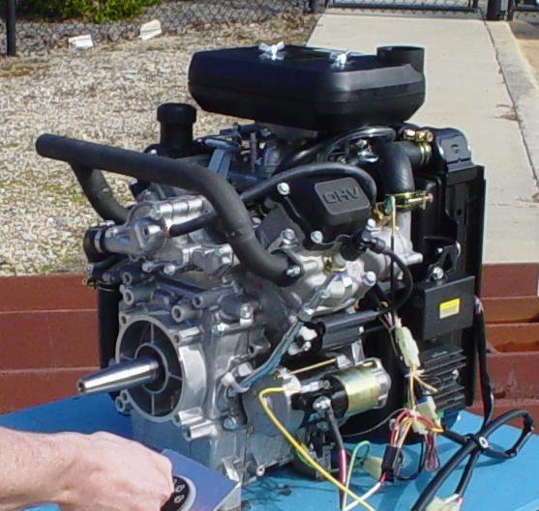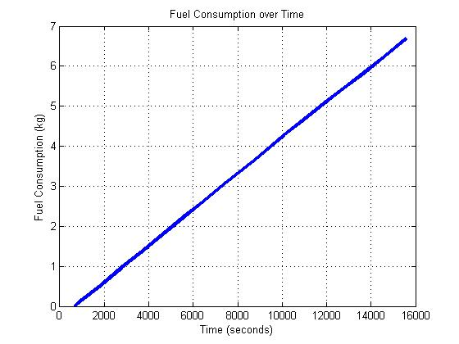
Figure 1.

Exhaust gas initial and final temperatures of the inlet (at the header) and outlet were also monitored. A graph showing these values vs. the time of the test run can be seen in Figure 1 and Figure 2. The exhaust gas inlet temperature initially jumps to a temperature of 693°C while the exit temperature stays relatively constant at 50°C. The slight drop of the exit temperature correlates to the time periods where the water tank was partially drained and refilled in order to keep it from overheating.
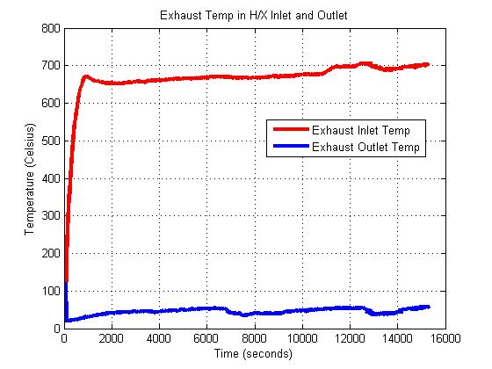
Figure 2. Labview data collected from exhaust inlet and outlet temperatures
4-2 Electricity Generation

The generator was chosen according to the power rating of the engine. A VOLTmaster, AB60 AC generator was selected providing 5000 Watts (41.7 Amps) of continuous electrical power. It requires a minimum of 11HP input power. This is a single phase two bearing generator which produces the desired 120/240 Volts when coupled to an engine operating at 3600 rpm. A picture can be seen below in Figure 3.

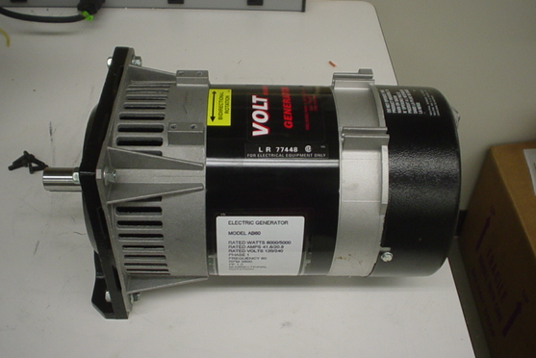
Figure 3.

A Lovejoy jaw type coupler was chosen because it allows for a small misalignment and is relatively inexpensive. This type of coupler easily attaches to the engine shaft by use of a set screw. Since the shaft of the engine is tapered the coupler had to have matching tapered bore machined into it as well. A picture can be seen below in Figure 4.

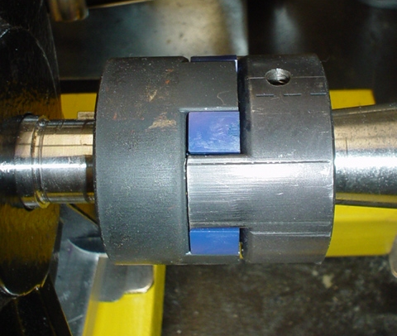
Figure 4.

4-3 Absorption Refrigeration

The tri-generation prototype provides a cold space powered by waste heat. The cold space chosen is a heat absorption refrigerator. This type of refrigerator uses the hot exhaust gas from the internal combustion engine to drive the cooling process. The absorption system heats a water and ammonia solution. The solution is heated and condensed during its cycle. During the cooling portion of the cycle, the ammonia vapor turns into liquid. As the system cools, the pressure drops, causing the liquid ammonia in the evaporator to boil and absorb heat. The unit requires 115 W of power which is compatible with the amount of heat available from the engine exhaust gas. The refrigerator was modified with a conduction circuit which is a solid copper rod that draws heat from a nearby pipe carrying hot gas. The conduction circuit was engineered to maintain a temperature of 3ºC in the cold space. The user manual, supporting calculations and test data are provided in Appendix A-3. The cold space is featured below in Figure5 and Figure 6.

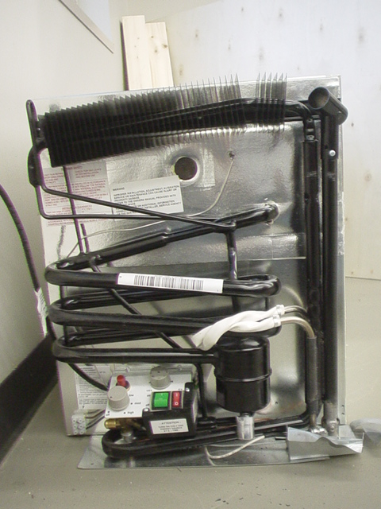
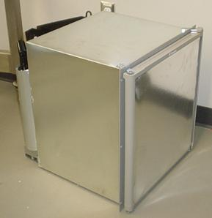
Figure 5. Heat Absorption Refrigerator Figure 6. Rear View

4-4 Water-Heating Unit:

In the current system there is a water-heating unit. The exhaust gas transfers heat to water via a spiral plate counter-flow multi-pass heat exchanger. Figure 7 shows the current heat exchanger. The water is then cycled through the heat exchanger by a re-circulating pump shown in Figure 8and stored in water tank (shown below in Figure 9).

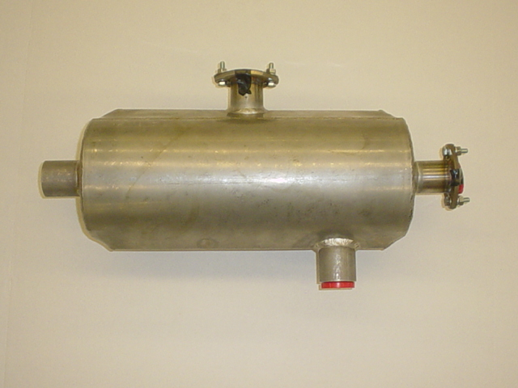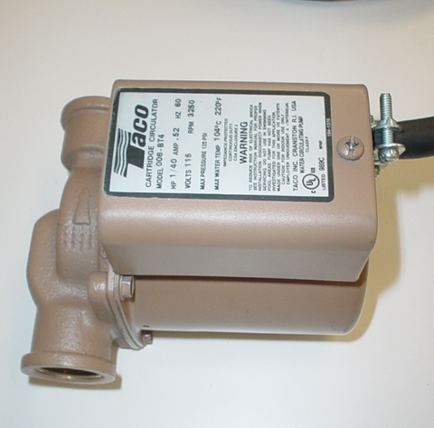
Figure 7 Heat Exchanger Figure 8 Water Pump

The current pump for the system delivers the water at 10 GPM (6.31x10⁻⁴ m³/s) at 2 ft. (60.96 cm). The pump can only handle water temperatures below 100 ºC. The heated water is then stored in a 20-gallon water tank.

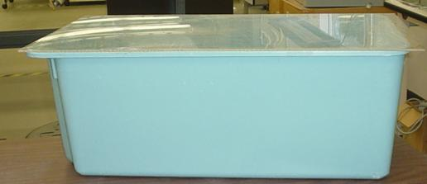
Figure 9 Water Tank

When the tri-generation is run, the water in the water-heating unit heats up far too quickly. While it takes the absorption refrigerator 2 hours and 56 minutes to reach its steady-state temperature of 3° C, it took the water-heating unit only 1 hour and 43 minutes to reach its maximum allowable temperature of 95 °C. Therefore, the water in the water tank had to be partially emptied and refilled in order to prevent the water pump from getting damaged.

V. Product Specifications

I. Refrigeration Specifications
1-1: The temperature in the absorption refrigerator will be controlled by a thermostat and range from 3º to 20º C.
1-2: The prototype must have a heat bypass to prevent heat from reaching the conduction circuit.
1-3: The heat bypass must reroute hot gas with a butterfly valve controlled by a rotary actuator.
1-4: The rotary actuator will be signaled by the programmed temperature (between 3º and 20º C) on the thermostat, turning the butterfly valve 90º to reroute the hot gas.

II. Water Heater Specifications
2-1: The maximum temperature of the heated water is to 95°C.
2-2: The water-heating unit should be maintenance-free and refilled for a minimum period of three hours while the system is operating.

III. Alternative Fuel Sources
3-1: The system must be able to run on a fuel other than gasoline.
3-2: The alternative fuel must be gaseous and in a compressed state.
3-3: The engine must be adapted to safely run on the fuels maintaining 3600rpm
3-4: A second cool environment must be created using only the cooling caused by the expansion of the gaseous fuels.

IV. The Overall System
4-1 The entire system must fit within a four-wheeled workbench for easy portability. 38.3”w x 55.5”l x 31.5”h, two tier frame.
4-2 The system’s internal combustion engine must run at 3600 rpm.
4-3 The system must produce 120V of electricity.
4-4 Entire system must be designed, built and tested within the given budget of $3000.00.

VI. Concept Generation and Selection

From the problem statement and design requirements, the group has come up with the following concepts addressing the need for alternative fuels, the need for water management for the water-heating unit and for temperature control for the conduction circuit.

6-1: Heat Bypass Conceptual Designs

The prototype will have a heat bypass design to regulate the temperature in the cold space. Currently the prototype supplies a constant supply of heat to the absorption refrigerator. The heat bypass will interrupt the heat flow and allow for temperature regulation in the cold space. An absorption type system does not use a compressor but instead uses a generator.

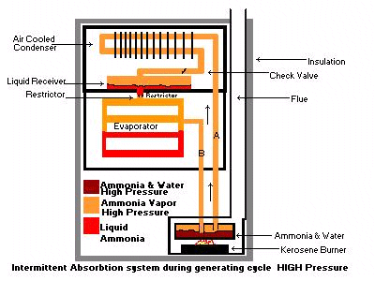
Figure 10.

The intermittent absorption system shown in Figure 10 uses a generator charged with water and ammonia. A heat source heats this solution in the generator. The ammonia is vaporized and driven off. A condenser, at the top of the system, condenses the ammonia vapor into a liquid. The liquid flows by gravity into the liquid receiver shown above and then into the evaporator. During the generating cycle, little or no refrigerating effect is taking place. As the system cools, the pressure drops, causing the liquid ammonia in the evaporator to boil (flash off) and absorb heat.

The heat source to the refrigerator is a piece of copper pipe that acts as a conduction circuit. The first design option for the heat bypass modification will consist of a valve and pipe bypass. How this design fits into the current system is shown below in Figure 11. The high temperature valve will reroute the exhaust gas before it reaches the conduction circuit. The bypass pipe will route the exhaust gas directly into the heat exchanger. The valve will be controlled by a pneumatic or electronic actuator. An actuator is a piece of equipment that produces movement when given a signal. Actuators are used in the computer control of an environment. The actuator will be signaled by the desired temperature in the refrigerator.

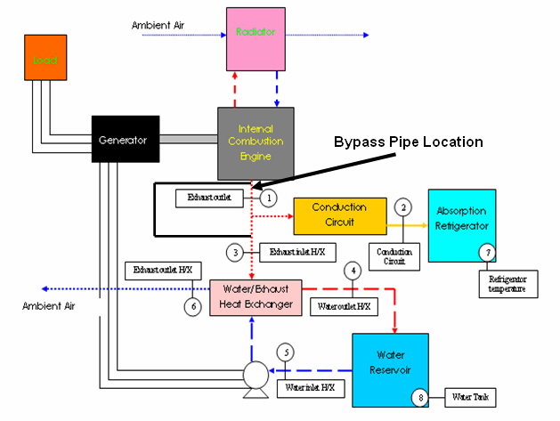
Figure 11: Depiction of Bypass
Pipe Location

The second design would allow for a physical separation in the conduction circuit. No heat will be conducted from the exhaust gas to the refrigerator. The movement that breaks the conduction circuit will be regulated by an actuator. The actuator will receive a signal based on the temperature in the refrigerator. How this design would fit into the current system is depicted below in Figure 12.

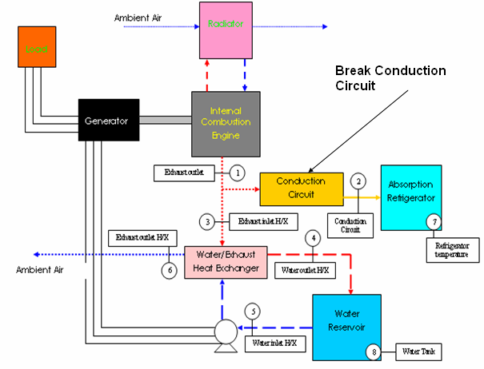
Figure 12: Depiction of Current System with
Break Conduction Circuit addition.

6-2: Heat Bypass Design Selection

After considering all of the conceptual designs in controlling the heat to the absorption refrigerator the selection can be made. Based on the problem presented either design should be equally effective which makes the governing criteria cost and physical constraints. Meaning, a conceptual design may be more affordable in theory but may be impractical with the given space constraints. To facilitate the heat bypass effectively and economically a butterfly valve will be used to redirect the hot gas away from the absorption refrigerator’s conduction circuit. The valve will be controlled by a rotary actuator. The actuator will be signaled by the programmed temperature on the refrigerator’s thermostat. Fabrication will be required to make the design more cost effective. Drawings and schematics of the final design are provided in Appendix C-1. The decision matrix used in coming to the conceptual design selection is shown below. All criteria are equally weighted.

 | Cost | Meets Requirements | Ease in adding to current system | Total
Valve and Pipe Bypass System | 1 | 3 | 2 | 7
Break Conduction Circuit | 2 | 3 | 1 | 6
Rank on how well concept meets criteria: 3: great extent, 2: some extent, 1: slight extent, 0: no extent

6-3: Water Management Conceptual Designs

The following conceptual designs were fabricated based on the need for a way to keep the water-heating unit from getting damaged due to the temperature reaching a maximum temperature of 95°C only 1 hour and 43 minutes into the process. The three concepts under consideration are adding an automatic bypass system with distiller addition, adding a water-heating unit bypass with distiller addition and increasing the water reservoir size.

The first concept considered was an automatic bypass system with an addition of a distiller. This concept is based on a system that would control the heat into both the conduction circuit and the water-heating unit. The excess heat would then be used to generate steam that would be used in a distiller. The modification to the current system is shown below in Figure 13. This concept would help solve two current problems of excess heat to the absorption refrigeration and the water-heating unit. The added distiller would use the excess heat from the exhaust to generate steam.
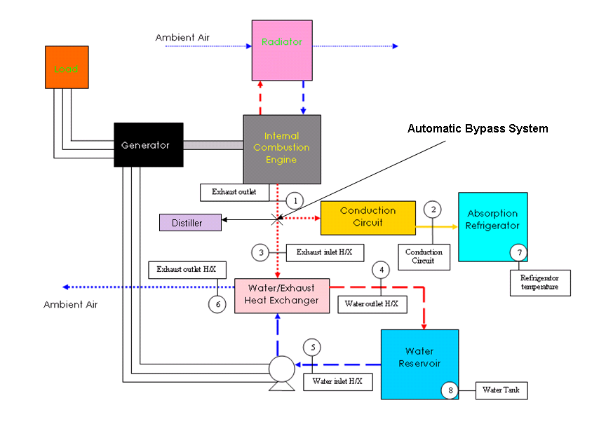
Figure 13:Modification to System with addition of Automatic Bypass System
The second concept being considered was one with a water-heating unit bypass and an addition of a distiller. This system involves controlling the heat input into the water-heating unit. The modification to the current system is depicted in Figure 14. The figure depicts the placement of the bypass before the heat from the exhaust reaches the heat exchanger. The heat from the exhaust would go to a distiller and the water-heating unit. The heat to the water-heating unit would also be controlled manually by a valve so water is heated only when needed by the user. This design would prevent overheating of the water-heating unit since the water-heating unit would only be used when needed. All of the waste heat then would be redirected to run a distiller that would provide freshwater.

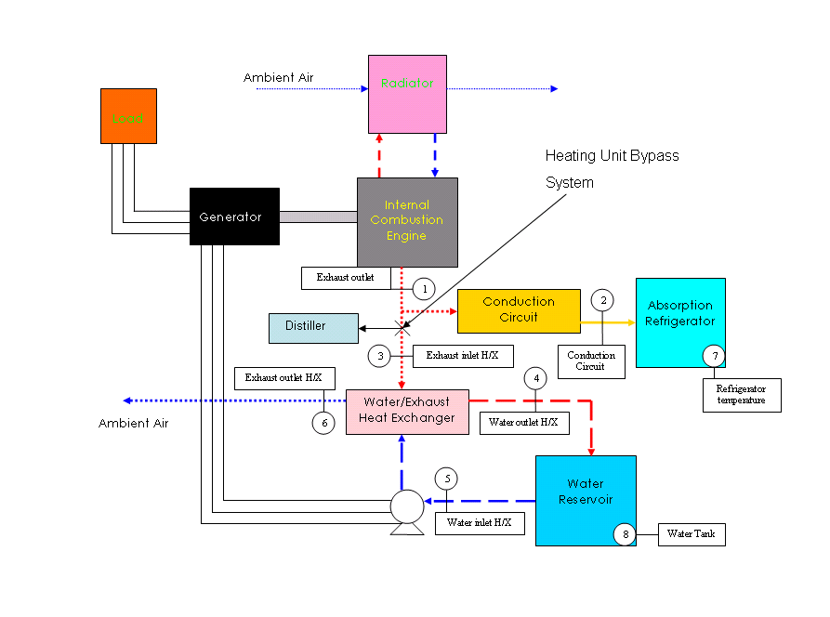
Figure 14: Modification to System with Heating Unit
Bypass System and Distiller

The third concept under consideration involves increasing the size of the water reservoir. The modification to the system is shown in Figure 15 below. By increasing the size of the water reservoir, more heat from the exhaust can be absorbed and overheating would no longer be a problem. Increasing the water tank size though may make the whole unit cumbersome to transport but it would be the most cost effective option.

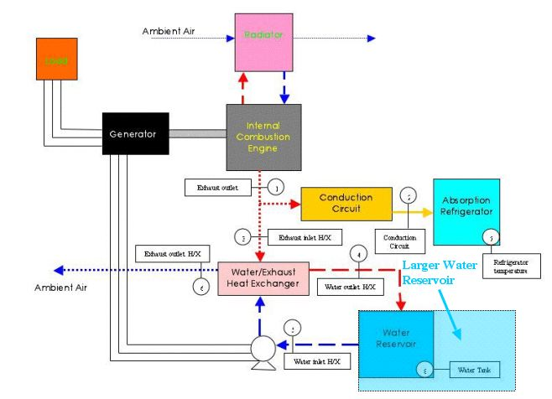
Figure 15: Modification to System by increasing
Water Reservoir size.

6-4: Water Management Conceptual Design Selection

After exploring all of the conceptual designs in controlling the temperature of the water-water heating unit, the selection can be made. Certain criteria must be looked at and how each concept applies it must be taken into consideration. From the problem statement and budget constraints cost, ease into fitting into current system and being able to reduce the temperature from 46°C to 95°C are the most important criteria involved. A decision matrix is depicted below showing how each option ranks according to the criteria.

Decision Matrix
 | Cost | Meets Temperature Specifications | Ease in adding to current system | Safety and Control | Total
Automatic Bypass System | 1 | 3 | 3 | 1 | 8
Water Heating Unit Bypass | 1 | 3 | 2 | 3 | 9
Increasing Water Reservoir Size | 3 | 2 | 1 | 1 | 6
Rank on how well concept meets criteria: 3: great extent, 2: some extent, 1: slight extent, 0: no extent

The first criterion is cost. The cheapest of the three is increasing the tank size of the water reservoir, while both bypass systems with distiller additions are the more expensive options. The second criterion is for the concept to be able to meet the temperature specifications. In meeting the temperature specifications, the water reservoir must not go above the maximum temperature of 95°C. The automatic bypass system with added distiller would meet this criterion by only allowing a limited amount of heat (limited dependent on user’s current need of fresh water or hot water) into the water-heating unit rather than a constant supply of heat. The water-heating unit bypass with added distiller would also meet the temperature specifications since heat would only go to the water-heating unit when the user wanted hot water, any other time, the heat would go to the distiller. For the larger water reservoir size, the temperature specifications would just barely be met with the temperature getting very close to the maximum after three hours. The third criterion is the ease in which each concept is integrated into the current system. Both the automatic bypass system with added distiller and the water-heating unit bypass would be easily integrated into the current system. For increasing the water tank size, this may cause a problem because the tank size would be large and the cart holding the whole system would have to be reengineered.

The fourth criterion is safety and control. Having control over an individual subsystem is important if maintenance is required while the system is in operation. This can also be a safely issue as well. When looking at the automatic bypass concept, there is not individual control over the distiller and water-heating unit. Making the tank larger adds no more control to the system, so it has a low rank for the safety and control criterion. The water-heating unit bypass gives the most control over the system also making it the safest. This concept receives the highest rank regarding this criterion.

After evaluating how each concept rates with the criteria, the optimal conceptual design is the water-heating unit bypass system with added water distiller.
The groups decided to come up with a modification that involves redirecting the heat from the exhaust via a bypass piping to instead heat up water in a water distiller that will produce clean water. The bypass allows all of the heat from the exhaust to go to the distiller and heat only goes to the water-heating unit when the user needs it.

The distiller that will be used is the Waterwise Non-electric Water Distiller. It is depicted below in Figure 16 and Figure 17. This water distiller is made from stainless steel and can hold 4 liters of water within the boiler.
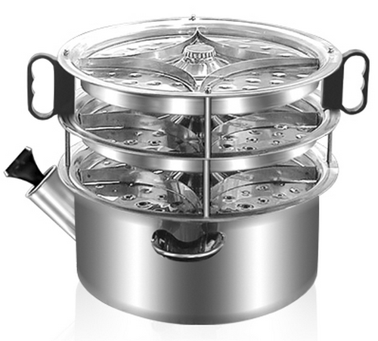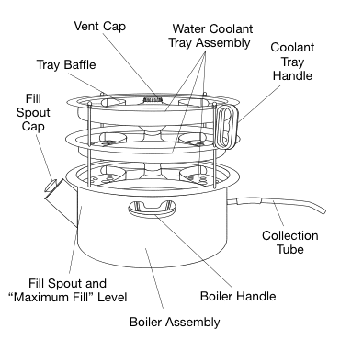
Figure 16. Figure 17.
In water distillation, water is placed in a boiling chamber and boiled. The water then becomes water vapor and exits the boiling chamber leaving behind impurities. Once the water leaves the boiling chamber is condensed back into a liquid by being cooled in a cooling section and then collected in another container called the collector. One of things that must be taken into account when distilling water is the removal of synthetic compounds (e.g. volatile organic compounds (VOC), pesticides and some volatile solvents) that have a boiling which is lower than water. Since these synthetic chemicals have a lower point than water, they are vaporized and condensed with the water. To avoid having contaminated water, one can use gas vents or a carbon filter. The group decided that a carbon filter would be the cheapest and most simple way to remove these synthetic chemicals. The distiller that has been chosen has a carbon filter in it cooling section and all of the impurities are removed before being collected in the collector.

By redirecting the engine’s exhaust to the water distiller by means of a bypass system, the water-heating unit has been modified so that the water tank does not have to be constantly emptied and refilled while the whole system is working. This modification also takes advantage of the wasted heat and adds another feature to the tri-generation system by distilling water.

6-5 Alternative Fuel Conceptual Designs

The engine powering the Tri-generation system is to be converted to run on some alternative fuel in addition to gasoline expanding the system’s capability. Originally, the alternatives being considered were ethanol, hydrogen, natural gas, and propane. The advantages of using alternative fuels are many. All of the options being considered have lower emissions than gasoline. Ethanol has proven to be effective and reliable, with a proven track record as an alternative to gasoline automobiles in many countries.

Regarding the gaseous fuels, natural gas, propane, and hydrogen, the engine life should be increased with the conversion. Lubricating oil life is extended significantly because these fuels do not contaminate and dilute the crankcase oil. The lead effects on the plugs associated with gasoline usage are completely eliminated and plug life is significantly extended. Perhaps the main reason the engine life would be extended is that gaseous fuels enter the engine in the form of a gas while gasoline must be mixed with the air in the form of spray or mist. This spray slowly washes away the lubricating oil from the piston ring, increasing the wear and tear of the engine. Overall, the maintenance costs are reduced and engine life is increased with gaseous fuels.

Hydrogen is the first fuel to be considered for use. Hydrogen has a high octane rating, 130 compared to 87 of gasoline. Unlike most people think, accident experience suggests that the danger involved with a rupture in a hydrogen tank is somewhat lower than with gasoline, due to the fact that it dissipates quickly. It is highly explosive though and if released in a confined space, it can become extremely dangerous.

The main problem regarding hydrogen is that while hydrogen supplies three times the energy per pound of gasoline it has only one tenth the density when the hydrogen is in a liquid form and very much less when it is stored as a compressed gas. For our purposes, it would be used in its gaseous state, requiring very large tanks to store the necessary amount of fuel. Storing 25 kg of gasoline for example requires a tank with a mass of 17 kg, whereas the storage of 9.5 kg of hydrogen requires 55kg.

Compressed Natural Gas (CNG) is the second fuel to be considered. It has long been considered to be an environmentally “clean” alternative to petroleum based fuels. It is made by compressing the methane (CH₄) extracted from natural gas. CNG also has an octane rating of about 130. If handled correctly CNG can produce the same, or more power output from an engine.

CNG has four big safety features that make it an inherently safer fuel than gasoline. Firstly, CNG has a specific gravity of only 0.587, meaning it is lighter than air. In case of any leaks, the gas will just rises up and dissipates into the atmosphere. Secondly, it has a self-ignition temperature of 700 degree centigrade as opposed to 455 degree centigrade of gasoline, increasing reliability and efficiency. Thirdly, CNG has to mix air within small range of 4 to 14 percent by volume for combustion to occur, much narrower than gasoline.

In response to high fuel prices and environmental concerns, compressed natural gas has been used in light-duty passenger vehicles and pickup trucks, medium-duty delivery trucks, and in transit and school buses, so there is extensive real life experience.

In all, CNG proved to be an attractive option from the beginning.
Propane is the third fuel to be considered. Propane has an octane rating of about 104. Unlike natural gas, propane is heavier than air so in its natural state, propane will sink and pool at the floor. It also has a high energy content, 26,900 kJ/L. Propane combustion is also much cleaner than gasoline, though not as clean as natural gas. One thing that makes propane an attractive choice is the fact that it is readily available. It can easily be found in supermarkets, gas-stations, and department stores.
Ethanol was the other fuel considered. In terms of ease of conversion, ethanol initially seemed like the best choice. In terms of physical characteristics, it is the closest of the alternative fuels to gasoline, considering all the other choices are gaseous in nature. In addition, ethanol has been used as an alternative to gasoline for a long time, and recent advances in engine technology have produced vehicles able to run on both gasoline and ethanol without any manual adjustments. It also contains a much higher octane rating than gasoline, about 118.
One of the disadvantages of ethanol is that it has a lower energy content than gasoline (about 30% less energy per unit volume). In addition there have been examples of corrosion of ferrous components and formation of salt deposits. The use of ethanol-based fuels can also negatively affect electric fuel pumps, due to increased internal wear and undesirable spark generation.

As work on the project progressed and the objectives were defined it was decided that we would like to add another cool space to the existing system. Considering the fact that the gaseous fuels must be stored a pressures higher than atmospheric and that the pressure must be lowered before inserting the fuel into the engine, we decided that we could use that expansion of the gas to cool the second cold space. That ruled out the possibility of using ethanol. From then on, we focused on the other options, hydrogen, CNG, and propane. Next, it was necessary to analyze the conversion process for each alternative fuel in order to make the best selection. Looking at the conversion kits available in the market, there are 3 main conversion methods involving gaseous fuels: spud in, adapter, and carburetor replacement.

The kits that use the spud-in method are normally the lowest cost method of conversion, but definitely not the easiest to install. Installation involves physically modifying the carburetor by drilling a hole in it, thus permanently disallowing the use of gasoline by the engine once installed.

The carburetor replacement method is simply that. It replaces the gasoline carburetor with a new carburetor containing a correct 21enture for the engine and application. These kits give the best consistent power and performance and are the easiest to install. Like the spud-in conversion method, it won’t allow the use of gasoline.

Cost and installation time of the adapter method usually fall between the other two methods. The carburetor adapter is installed between the gasoline carburetor and the air cleaner. The adapter method allows dual-fuel operation or it leaves the option of converting the engine back to gasoline in the future. Under full load the adapter method may cause a slight loss of power though, because of the greater air restriction due to two venturis in the system.

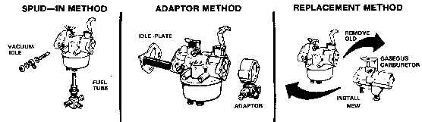
Figure 18

6-6 Alternative Fuel Design Selection

Hydrogen conversion kits are generally more expensive, already adding to the higher cost of the fuel. The kits for CNG and propane both generally work the same way. First, regulators lower the pressure gradually, with the first reduction being the largest one. This first part of the process would be bypassed, with the expansion of the gases to be used to cool a second environment. Once expanded, with its pressure lowered, the fuel would then be introduced into the converter.

Looking at each fuel and the necessary conversion kits, the selection can finally be made. Cost, availability and ease of installation are the most important criteria involved in the decision. A decision matrix assisting in fuel selection is shown below.

 | Ease in Integration into Current System | Cost | Availability | Total
Hydrogen | 2 | 1 | 1 | 4
Compressed Natural Gas | 3 | 3 | 2 | 8
Propane | 3 | 3 | 3 | 9
Rank on how well concept meets criteria: 3: great extent, 2: some extent, 1: slight extent, 0: no extent

The need for the current fuel to be integrated into the current system is met by all three of the alternative fuel sources under consideration. The second criterion is cost. The high costs outweigh the advantages when it comes to hydrogen. The conversion kits for both CNG and propane are relatively inexpensive, with prices ranging between $150 and $300. The third criterion is availability. As for the decision between propane and CNG, due to the simple fact that propane is more readily available than compressed natural gas, would make it a more attractive option. Looking at all of the criteria, the alternative fuel originally chosen was propane.

After further investigation of the expansion process with the teammates in Brazil, it was decided that propane wouldn’t provide enough of a temperature drop during the expansion. Its standard storage pressure is simply too low to make the system work as desired, so a change was made to CNG as it can be stored at pressures of 3000 psi and above.

Once the alternative fuel was chosen we began the search for an appropriate conversion kit that fulfils all the requirements. Two companies had conversion kits for our engine; Carb Tubo and USA Carburetion. Prices for both were about the same, $243.75 for Carb Turbo’s and $267 for USA Carburetion’s. Due to slight price advantage and better customer support, the kit #720-FD501-5 from Carb Turbo was selected. A picture of an adapter is shown below.

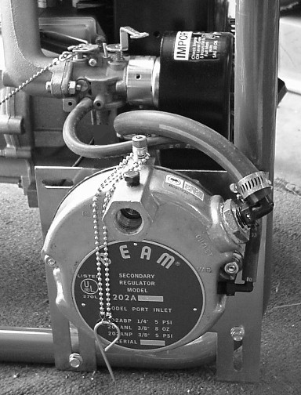
Fig. 19 (Photo of an Adapter Installed on a Tecumseh HM100 Engine)

Gas Expansion

The Brazilian team members are currently working on the cooling effects of the expanding gas. The negative heat from expanding gas will be incorporated into the trigeneration prototype and aid in generating a cool space. As the compressed gas is released from the storage tank the gas expands and generates a temperature drop. The gas will be conveyed through piping that will incase a cool space and aid in cooling the space. The tank required to contain the compressed gas will need to be comparable to 18 gallons of gasoline so running time can be similar in duration. The calculations from our team members are pending.

Conclusion

In conclusion the modifications to the trigeneration system will be to add a heat bypass design that will incorporate a damper, rotary actuator, and additional piping to reroute the exhaust gas from the engine. Also, further modifications include the addition of a distiller to add versatility to the prototype, increase the prototype’s efficiency, and solve the water management issues with the current prototype. Theoretical calculations for the expected effects of the distiller addition are included in Appendix D-1. The last modification to the prototype is the introduction of alternative fuels. This also adds to the versatility of the prototype and increases the efficiency of the prototype by using the cooling effects of the alternative fuel (compressed gas). Theoretical calculations for the expected effects of the alternative fuel are included in Appendix D-2.

VII. Conclusion
The goal of this project is to modify a portable tri-generation system that was designed for the simultaneous production of electricity, hot water and refrigeration. The prototype that was inherited uses an internal combustion engine as the power source. The existing elements of the prototype are electricity produced by an AC generator coupled directly to the engine shaft, hot water by transferring heat from the exhaust gas to the water through a spiral plate heat exchanger, and refrigeration produced by heat absorption from the engine’s exhaust gases.
The modifications to the existing system are to improve prototype’s current efficiency of 42.1%. This will be achieved by the addition of a distiller, introduction of compressed natural gas and propane alternative fuels, introduction of cooling effects from the gas expansion, and automating the refrigerator’s temperature with the selected heat bypass design. The system will run off of two fuels and a conversion kit will be added that allows for gasoline and compressed natural gas to be used. Compressed natural gas (CNG) is stored at a high pressure and must be at a lower pressure when it enters the conversion kit. As the gas expands, the cooling effect will be used for a cool space. a bypass system will be installed. A high-temperature valve that will reroute the exhaust gas will control the heat supplied to the refrigerator. An actuator signaled by the refrigerator’s temperature will control the valve. The water-heating unit exhaust gas will also be redirected by a high-temperature valve and bypass piping to a water distiller. The improvements will be made with a budget of $3,000 with a cost analysis and parts list included in Appendix F.

VIII. References

- Tracy, Thomas Jr., et al. Development of a Tri-Generation System: Final Design Package, Spring 2006. CAPS 1: Integrated Heat Recovery System.
- Tracy, Tom. “Development and First Law Analysis of a Tri-Generation System.
- Çengel, Yunus A. and Robert H. Turner. Fundamentals of Thermal-Fluid Sciences 2nd Edition. New York, NY: McGraw Hill Higher Education, 2005.
- Janna, William S. Design of Thermal Fluid Systems 2nd Edition. Boston, MA: PWS Publishing Company, 1998.
- WaterWise Model 1600 Non-electric Water Purifier/Distiller Use and Care Guide. 2001 Waterwise Inc. www.waterwise.com
- Natural Gas Information and Education Resources. 2004 www.naturalgas.org
- Carburetion & Turbo Systems. www.carbturbo.com
- Heywood, John. Internal Combustion Engine Fundamentals. McGraw Hill College, 1988.

Appendix A: System User Manual and Parts List

Trigeneration Prototype User’s Manual

Warnings and Precautions

- Run system in a well ventilated area.
- Do not fill fuel tank while engine is running or hot.
- Do not use open flame near the system.
- Store fuel only in approved containers and in a well ventilated area.
- Guard against electric shock.
- Avoid contact with live wire terminals or receptacles.
- Use caution when handling or servicing the battery.
- Avoid water contact with battery. Shut off system if this occurs.
- Do not disconnect battery cables while system is on.
- Use extreme caution when working with electrical components. High output voltages may cause injury.
- Avoid hot engine parts, piping and exhaust gas which can cause severe burns.
- Make sure all safety guards and insulation are in position and tightly secured before operation of system.
- Do not allow water above 200°F (93°C) to pass through the heat exchanger.
- Do not allow cool water to pass through the heat exchanger when hot. This will cause flash boiling and damage to the system.
- Do not place anything over 75 lbs on scale.
- Do not leave standing water in reservoir for extended periods of time.

Overall Operation

Prior to turning the system on:
- Attach the fuel line to the fuel filter.
- To measure fuel consumption place fuel tank on scale next to the table on top of the stand.
- Turn scale readout on.
- Tare the scale (refer to owners manual for instructions). As fuel is being consumed the scale will read negative values.
- Press start on the timer when engine is turned on.
- If fuel consumption is not being measured place scale on bottom tier of table.
- Plug in the re-circulating pump to the receptacle at the rear of the generator.
- Check that all engine fluids are at proper levels.

Turning the system on:
- Put choke, located on the control panel, in closed position (lever in top position). See diagram below.
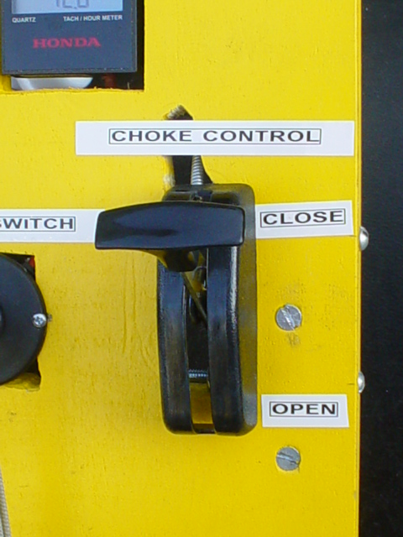
- Turn the key to ignition start position until engine starts and release.
- When the engine starts, gradually move the choke to open position (lever in bottom position). See diagram below.
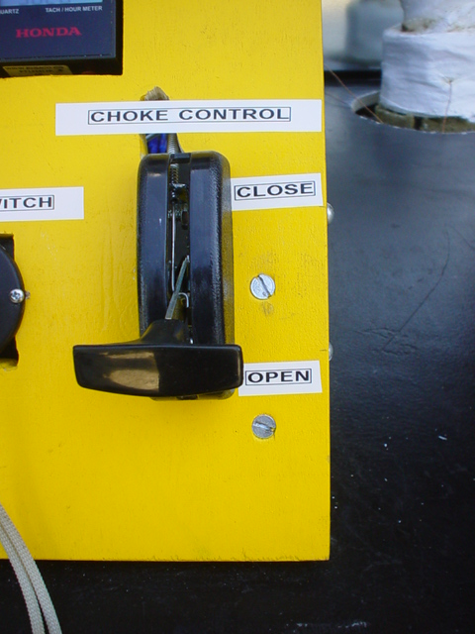

While the system is running:
- Water must always be circulating while system is turned on to avoid overheating of heat exchanger and connecting pipes.
- Monitor water temperature in tank. Boiling water cannot enter heat exchanger or pump.
- If temperature exceeds recommended amount drain half the tank and refill with cool water.
- Do not refill more than half of the reservoir with cool water while system is running. Cool water cannot enter a hot heat exchanger, flash boiling will occur.
- To cool the heat exchanger the system must be turned off for at least 3 hours or until the heat exchanger temperature falls below 100°C.
- Monitor the rpm of the engine. The engine must remain at 3600 rpm (+/- 150 rpm) to avoid damage to the generator and load.
- If the rpm exceeds or falls below recommended amount remove load from generator. Adjust the rpm of the engine by the same amount.
- Turn throttle set screw to the right to lower and to the left to increase the rpm. Retighten the locknut. See diagram below.
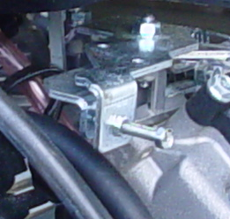

LabVIEW testing procedure:
- Plug in LabVIEW testing station.
- Turn the card reader on.
- Plug the thermocouple card reader into the thermocouple box.
- Turn on the computer.
- Double click the LabVIEW icon that says “senior design DAQ”.
- A window will pop up showing temperature readings from each thermocouple with labels showing what temperature it is measuring.
- Click the “start recording” button when engine is turned on.
- Click the “stop recording” button when data acquisition is complete.
- Raw data is sent to the “senior design data” folder on the desktop. Each run is automatically placed in this folder labeled with the date.
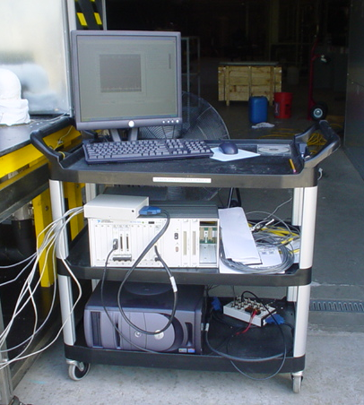
Thermocouple box
Card Reader
PC Tower

Maintenance
After every 25 hours of operation:
- Change engine oil and oil filter.
- Replace spark plugs.
- Drain and fill radiator with new 50/50 coolant mixture.
- Replace air filter.
- Replace fuel filter and check for cracks in fuel line.
- Check battery terminals for corrosion. If corroded clean thoroughly.
- Clean and tune engine carburetor.
- Check for wear of all insulation. Replace if needed.
- Clean water tank and piping.
- Check coupler alignment. Adjust if necessary.
- Check ignition wiring for deterioration. Rewire with new terminals if necessary. See diagram on next page.

Current System Parts List

Unit | Component | Sub-Component | Qty | Description
Frame
 | Stainless Steel Frame |  | 1 | Frame Donated to Team
 | Table Top |  | 2 | 3/4in thick 4' x 8' sanded pine
 | Table Support
 |  | Wood Beam | 4 | 2" x 4" 96" long
 |  | 5/16" Dia x3" screw | 16
 |  | Cut washers | 16 | 5/16" cut washers
 |  | Wood screws | 2 | 1.5" Long wood screws
 |  | Bolts | 3 | 0.25" Dia x 2" Long
 |  | Sand paper | 1 | Assorted Grit
 |  | Paint | 1 | High heat bulk oil based
 |  | Brushes | 1 | Paint rollers, brushes
 |  | Acetone sol | 1
 |  | Acetone sol | 1
 |  | Spray paint | 2
 |  | Cut washers | 8 | 5/16"
 |  | Bolts | 6
 |  | FND washers | 4 | 5/16" diameter
 |  | Stl clamp | 3
 |  | Stl clamp | 3
 |  | GE clear tube | 1 | Silicon sealant
 |  | U-Bolt | 1
 |  | Washer | 2
 |  | Tape | 1 | 1/2*260 tape
 |  | Nuts | 4
 |  | 5/16 Nuts | 4
Engine
 | Engine Unit |  | 1 | Kawasaki Model # FD501D-S05
 | Fuel Line |  | 1 | 10 Ft 1/4" vinyl tubing
 | Rubber Mounts |  | 2 | 1/2" thick 12"x12" rubber mat
 | Gas1 |  |  | 6 Gallons
 | Gas2
 | Gas3
 | Ignition Switch |  | 1 | 5 terminal 3 way switch
 | Battery Cable Terminal |  | 2
 | Battery Cables |  | 2
 | Battery |  | 1 | Left Hand Regular Utility
 | Engine Oil |  | 2 | 10W30
 | Fuel Pump |  | 1
 | Primer |  | 1
 | Barb1 |  | 1 | 1/4 Hose
 | Barb2 |  | 1 | 1/4*1/4 Hose
 | Battery Box |  | 1
 | Fuel Tank |  | 1 | 6.5 Gallon
 | Fuel Line |  | 1 | 1/4" Diameter
 | Vacuum Caps |  | 1
 | Fuse Holder |  | 1
 | Wire Crimps |  | 1 | 10-12 gauge
 | Wire Crimps |  | 1 | 14-18 gauge
 | Manual |  | 1
 | Hose Clamps |  | 16 | #4 Clamp stainless steel
 | Cable Ties |  | 1 | 4" Long
 | Cable Ties |  | 1 | 11" Long
 | Wire |  | 1 | 16 gauge Black Ground Wire
 | SKT Cap |  | 4
 | Metric Bolts |  | 4
 | Wire Crimps |  | 1 | Assorted wire crimp set
 | Fuse |  | 1 | Ceramic,25 A
 | Ignition Switch |  | 1 | STENS# 31-9655
 | Ignition Key |  | 1
 | Gas Tank |  | 1 | 5 Gal
 | Engine Repair
 | Fuse |  | 1 | 25 Amps
 | Tachometer |  | 1
 | Throttle Control |  | 1
 | Coupler Machining
 | Shaft Coupler Body |  | 2
 | Insert, Urethane |  | 1
Generator
 | Generator Head |  | 1 | Voltmaster AB-60
 | Hexnut Ga |  | 3 | 5/16"
 | Hex Bolt |  | 3
Coupler
 | Woodruff Keys |  | 1
 | Engine Coupler |  | 1 | 0.5"Split taper bushing
 | Generator Coupler |  | 1 | 7/8" Split taper bushing
 | Rubber Gasket |  | 1 | Use Previous Rubber Mat
 | Jaw Type Coupler |  | 1
 |  | Machining Coupler
Refrigerator
 | Refrigerator Unit |  | 1 | Dometic RM2193
 | Rubber Mat |  | 1 | Use Previous Rubber Mat
 | Conduction Circuit |  | 1 | 12" long 3/4" diameter copper rod
 | RV Fan |  | 1
Water Heater
 | Water Container |  | 1 | 11" h x 17"w x 31"l plastic container
 | Water Heater H/X |  | 1 | Polar model 30 exhaust heat exchanger
 | H/X Mounting Frame
 |  | 2”X4” | 1 | Use Previous 2”X4”
 |  | Rubber mount | 1 | Use Previous Rubber Mat
 | Water Pump |  | 1 | Taco 1/40 hp 115V
 | H X bolt |  | 4
 | Strap |  | 1
Piping System
 | Tee |  | 1 | CxCxC 1" end 3/4" center
 | Rolled stop coupling |  | 1 | 5/8" CxC
 | Straight Pipe |  | 1 | 10 ft 1" nominal type L copper pipe
 | 90˚ Elbow |  | 8 | 1" C x C
 | Reduce Coupling |  | 2 | 1" to 3/4" CxC
 | Female Adapters |  | 2 | 1" CxF
 | Male Adapters |  | 2 | 3/4" male adapter FTGxM
 | Steel clamp |  | 2 | 4"-7" diameter
 | J B weld |  | 1
 | 90˚ Elbow |  | 3
 | Adapter |  | 2 | 1" Diameter
Insulation
 | Mineral Wool sheet |  | 2 | 24" x 48" 2" thick Metal mesh one side
 | Elastomer Foam pipe |  | 1 | 6 ft 1 1/8" diameter 1" thick
 | Elastomer Foam elbow |  | 9 | 1 3/8" diameter 1/2' thick
 | Polyethylene Sheets |  | 2 | 36" x 48", 1" thick
 | Mineral Wool Elbows |  | 3 | 1.25" diameter 2" thick
 | Casting Tape
 | Mineral Pipe |  | 3
 | Adhesive |  | 1
 | Repair Wrap |  | 3
Testing
 | Thermocouples |  | 5 | Hose clamp type K probes
 | Digital Scale |  | 1 | The Adamlab CPWplus35
 | Thermometer |  | 2
 | Battery1 |  | 1 | AAA
 | Battery2 |  | 1 | AA
 | Timer |  | 1
Miscellaneous
 |  | Stud | 1

A-1: Absorption Refrigerator Supporting Calculations and Previous Analysis

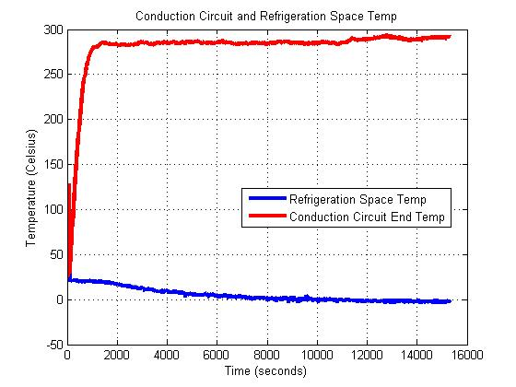
Conduction Circuit Calculations
Thermal conductivity of copper
Temperature needed for the boiler
Temperature of the exhaust gas
Energy input needed for refrigerator
Temperature at the top of the smaller diameter section of the conduction rod:
Length of the larger diameter section as a function of the exhaust gas temperature:
Temperature range for exhaust gas

The temperature inside the refrigerator steadily decreased until it reached a steady state temperature of roughly 3°C at time 2 hours and 56 minutes. The temperatures of the conduction circuit and inside the refrigerator then maintained these constant values for the duration of the test run.

A-2: Water Heating Unit Parts List and Previous Analysis

Parts Lists:
- Water Reservoir made from Plexi-glass with threaded PVC fitting and ball-valve
- Re-circulating Water Pump
- Spiral Plate Counter-flow Multi-pass Heat Exchanger from Polar Power Inc. (model 30)
- Waterwise Model 1600 Non-electric Heat Exchanger

Previous Analysis¹:
When the tri-generation system was run, it can be seen from Figure A-4-1 that the water initially at 23° C climbed to 95° C. It was determined that the water gained 1.6° C per pass in the heat exchanger.

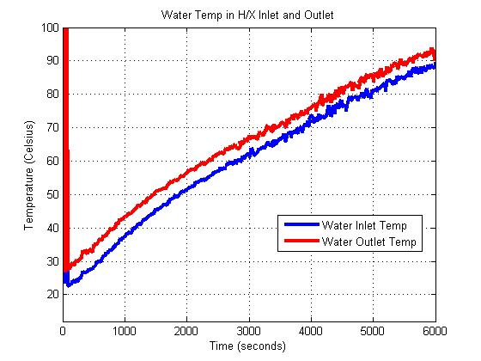
: LabVIEW Data showing the water temperature in the heat-exhanger.

By examing the figure above, it can be seen that the exit temperature of the exhaust stayed at about 50° C throughout the time interval while the inlet temperature stayed close to 693° C.
¹: LabVIEW Data showing the exhaust –gas temperatures in the heat exchanger.

Appendix B: Collaboration with Brazil

Appendix B-1: Meeting Minutes

Group Meeting: 19/September/2006

Attendees: Maggie Alvarado, Bruno Viera and Natalie Levings.

Objectives:
- Distribute tasks
- Finish Code of Conduct

Task Distribution
Brazil
Energy Conversion: working with alternative fuels and how to modify.

U.S.
Water Management
- Distiller: Bruno
- Heat Bypass: Maggie
- Heat Exchanger and Tank Management: Natalie
Communication
- Wednesday 12-5pm are good times
- We plan to have teleconferences bimonthly
- Meet with Dr. Ordonez every week
- Exhance e-mail addresses
Expansion
- Everyone research

For Next Meeting:
- Research assignments
- Have Code of Conduct signed
- Have a picture of us

Group Meeting: 20/September/2006

Attendees: Maggie Alvarado, Dr. Ordonez,Bruno Viera and Natalie Levings

Topics Discussed:
- Accomplished finding time for weekly meetings, teleconferences and video-conferences : Wednesday 2-5pm
- Things to be Completed:
  - Talk to Drew Kocur (Kocur@eng.fsu.edu) about video-conferences
  - E-mail Dr. Odonez by Monday 25 September all questions that we want him to ask Dr. Vargas when he sees him in Baltimore.

Staff Meeting: 21/September/2006

Attendees: Maggie Alvarado, Dr. Luongo ,Bruno Viera and Natalie Levings

Topics Discussed:
- Communication
  - Find out about teleconferencing (see Jon Cloos cloos@eng.fsu.edu)
    - How it gets billed
    - Is there international long distance
    - If international long distance not an option, buy a calling card
  - Look into doing net meetings
  - Once students are assigned to groups, get names and e-mail addresses (so that they can become registered on b.b.) to Dr. Luongo
    - File exhance
    - Chat
  - Communication with Brazil is one of the biggest things that we will be graded on
- Budget
  - Budget is not a problem

What is Needed Next Week:
- Scope of Project
  - Expectation: What this project has to accomplish. What’s expected at the end of the project (e.g. one is to control heat input to the refrigerator).
  - Background, pictures can be included.

- Needs Assessment
  - Laundry list of needs

Group Meeting: 4/October/2006

Attendees: Maggie Alvarado, Dr. Ordonez ,Bruno Viera and Natalie Levings

Topics Discussed (What Dr. O spoke to Dr. Vargas about):
- Controlling absorption fridge
  - F.S.U.
  - An option could be to bypass and come up with our own design, another could be to buy a new fridge
  - We need a high-temp valve
- Finding alternative fuel types
  - F.S.U.
  - Rich will be helping with this portion of the project
- Water management
  - F.S.U.
  - One option is to modify tank so that it dissipates heat more efficient (may need a bigger cart). A second option could be to generate steam to power something else.
- Expansion
  - U.F.P.R.
  - We have now two cool spaces, one for fridge, one from expansion

Action Items:
- Find out about high-temp valves and are we going to buy them or make them?
- E-mail Dr. O. about names of students in Brazil
- Find a cheap way to go to Brazil

Group Meeting: 4/October/2006

Attendees: Maggie Alvarado, Tom Tracy ,Bruno Viera and Natalie Levings

Topics Discussed:
- Fuel Sources to consider
  - Hydrogen (hotter exhaust)
  - Propane
  - Natural Gas
- Heat bypass
  - Brazil has a pneumatic bypass valve
  - For a high-temp valve the material of choice would be stainless steel and doesn’t have to be powered by engine
- Heat exchanger
  - Vary the output to get steam if you want

Staff Meeting: 5/October/2006

Attendees: Maggie Alvarado, Dr. Luongo ,Bruno Viera and Natalie Levings

Topics Discussed:
- Stress on how we must have video-conferences and show team-building
- Presentations
  - More of ideas and where we are going
  - Figure out how we are going to work with Brazil.

Video Conference: 25/October/2006

Attendees: Raphael Cavalcanti, Maggie Alvarado, Dr. Vargas, Richard Robards ,Bruno Viera and Natalie Levings.
Topics Discussed:

- Alternative Fuels
  - Dr. Vargas pointed about that Brazil is currently using natural gas. They have considerable knowledge about this and will be a great help in this area if we choose to use natural gas. Dr. Vargas also pointed out that using natural gas gave a slightly lower exhaust temp
  - We may want to look into using biogas as well, we may not want to use it but perhaps we can research it and put it in our paper about the possibilities of using it.
  - We need to figure out which one we are going to use and then get back to Brazil by Friday because this effects how they are coming about their decision for the expansion
- Two points that need to be fixed
  - How we need to fix conduction circuit. We may want to use a solenoid valve.
  - For the water heating unit, Dr. Vargas suggest that we eliminate the water pump and water reservoir, and run water through the heat exchanger and get a vapor. With this vapor we can condense it and get water. Or we can use it for distillation. May be adding another heat exchanger.
- Brazil adding the new fridge system in addition to what we have
  - They are taking care of expansion. Will be using regulating (expansion) valve. Raphael stated that they may want to use that negative heat to cool another part of the engine. Perhaps to help with energy improvement.
  - They will find the type of valve and see if we can buy it here and if not they will send one to us in the mail.
- Improving Efficiency
  - The main goal of this project is to improve efficiency.
  - Include environmental issues in analysis. Perhaps talking about ways to reduce emissions, environmental impact. Discuss how this system can apply to other energy systems in the U.S.
Action Items:
    - We need to decide which alternative fuel we are going to use and get back to Brazil on this.
    - The Brazilians will send us a video on different components of the system.
    - We need to talk to Dr. L about getting them on bb so they can send us the video
We discussed having a conference next week at 1:30. We will e-mail Raphael and see if we can switch it to 1pm.
We need to look into using Skype

Staff Meeting: 26/October/2006

Attendees: Maggie, Natalie, Bruno, Dr. Luongo

Discussed doing a work breakdown structure. See this site
http://en.wikipedia.org/wiki/Work_breakdown_structure
We write down big jobs then the tasks that go with them. We trade off with Brazil and then decide which ones are subcontracted. We then write the specifications or requirements for the tasks and the other group solves the problem, based on the spec.
- We will be judged on how well we interlock our project
- In our next presentation we need to say where things are and how the work is divided according to the WBS.

Group meeting: 31/October/2006

Attendees: Rich Robards, Bruno Vieira, Natalie Levings

Topics Discussed:
I. Work Break-Down Structures (Who will cover what parts)
Alternative Fuels
- Bruno Vieira
- Rich Robards
Conduction Circuit
- Maggie Alvarado
Water Heating Unit
- Natalie Levings
Alternator
- Rich Robards

These need to be finished by Friday morning so we can send them to the other group.

II. Conversion Kits
Discussed how we need to get a conversion kit soon b/c we want to test the unit with new conversion kit to get measurements for exhaust temperature. This is something that should be done before modifications are done to the conduction circuit and the water heating unit. We need to have a purchase order in by Monday.
Rich mentioned an e-mail about dates for purchase orders, Natalie requested that he forward that e-mail to her sometime today.

III. Agenda for meeting tomorrow
So far we would like to discuss the following with Raphael:
- Status of project
- Goals for the next week
- Conference times
- About pictures and about having a live meeting for presentation
If anyone wants to add anything else, get back to Natalie by 2pm today so she can e-mail Raphael in time.

IV. Presentation Next Week
We have our presentation next week, everyone needs to do their own slides. The presentation needs to be completed by Tuesday.

V. MSN Chat
To help so we can talk more easily everyone needs to sign up for an account on MSN messenger. Sign up for an account today and then e-mail Natalie your sn by 9pm. Later tonight Natalie will send an e-mail to everyone with everyone’s sn so that we can all communicated.
Action Items:
 |  | Due Date
Send anything else to add to agenda | Everyone | 2pm 31/October/2006
E-mail Raphael agenda topics for tomorrow’s meeting | Natalie | 3pm 31/October/2006
Sign-up For MSN accounts and send Natalie SN | Everyone | 9pm 31/October/2006
E-mail everyone’s SN | Natalie | 9:30 pm 31/October/2006
Complete WBS | Everyone | 3/November/2006
Complete Slides | Everyone | 7/November/2006

Video Conference: 1/November/2006
Attendees: Raphael Cavalcanti, Maggie Alvarado, Richard Robards, Bruno Viera and Natalie Levings.
Topics Discussed
- Issues of use of hydrogen as an alternate fuel
  - Storage tank may not be adequate for interchangeable use
  - Some tanks may have low pressure
  - Dual-intake system would need to be employed
- Kits Available
  - Motorcycle NG conversion kits
  - Normal vehicular kits with tweaked expansion valves
  - American dealer with kit for small generators (http://www.propanecarbs.com/small_engines.html)
- Heat Conduction Circuit
  - Bypass valve solution – valve selection + alternatives
  - Video demonstrating UFPR solution to be sent by Weds., Nov. 8 2006
- Live webcam presentation on Thurs., Nov. 9 2006
  - Meeting prior to presentation to discuss Raphael's participation
- Video walkthrough of a typical NG conversion process
  - Should be sent by Weds., Nov. 8 2006
- New conference times
  - Availability for 12-2 PM on Wednesdays
Brazil will be entering Daylight Savings Time from Nov. 5, 2006 onwards therefore being 3 hours ahead of Eastern Standard Time

Telephone Conference: 8/November/2006
Attendees: Raphael Cavalcanti, Maggie Alvarado, Bruno Viera and Natalie Levings.
Topics Discussed:
- Discussion of allowable pressures for tanks. What the allowable presure drop should be to be a sufficient cool space.

- Discussion how how Brazil’s system controlls heat flow.

- Conversion kits to be e-mailed to everyone to look at and decide on.

Video Conference: 15/November/2006

Attendees: Raphael Cavalcanti, Maggie Alvarado, Richard Robards, Bruno Viera and Natalie Levings.
Topics Discussed
- Conversion Kits
  - Carbturbo has kits available but not all of the valves are readily available yet
  - 3-valve system has better fuel economy according to Carbturbo technician
  - For our purposes, the 2-valve system seems to be an easier solution to implement
  - Prices are similar for differing valve systems from Carbturbo (do not include hose from tank to high-pressure regulator) yet more expensive than US Carbtech

- Walkthrough of Videos
  - Efficiency of UFPR system will be determined– will be sent via e-mail once value is known
  - Volumetric flow rate of natural gas for UFPR system will be calculated by Monday, November 20, 2006
  - Total volume and gross weight of UFPR gas storage tank will be determined and sent via e-mail
  - Pictures were posted on an online upload site (check e-mail). Will be posted on BB by Natalie.

Staff Meeting: 16/November/2006

Attendees: Maggie Alvarado, Bruno Vieira, Natalie Levings and Dr. Luongo

Topics Covered:

Preparation for Final Report (due 5/December/2006)

1) During the next couple of days everyone needs to start preparing an outline for how the final report will be organized

Helpful Hints:

a) Tell the story by referring to appendices (appendices should include things such as data, vendors, calculations, drawings, designs, etc.). The report should be written with enough visual aids to tell the story with no interruptions of long calculations, drawings, etc (there refer to appendices).

b) Show how UFPR and FSU are interacting and who’s doing what

2) For our next staff meeting, we need to have a rough draft of how we want

to organize our final report so that it can be reviewed with Dr. L

Feedback from last week’s presentation

For presentations there needs to be more interaction with the screen.

Feedback on Project Specs and Procedures

a) For Project Specs we need to look over and see what he wanted

b) For Procedures it should be rewritten for report on what methods

(not steps) that will be taken to get tasks done (e.g. how files will be exchanged b/w FSU and UFPR)

Action Items:

1) By next staff meeting a rough draft of how the final report will be organized needs to be prepared.
2) The Project Specs and Procedures need to be rewritten

Video Conference: 29/November/2006

Attendees: Raphael Cavalcanti, Maggie Alvarado, Bruno Viera and Natalie Levings.

Meeting Summary
- Updates on how everything is progressing.
  - Scuba tank consideration.
  - Fuel kit should be purchased by the end of this week.
  - Distiller kit will be decided on by next week.
- Discussion on test run to see how live feed works, scheduled for 12pm on Friday.

Action Items:
Natalie is to check with Dr. Luongo to see if our group can go first so that Diego can be notified about the time of presentation and e-mail Raphael back about what he says.

Appendix B-2: Work Breakdown Structures

Heat Bypass

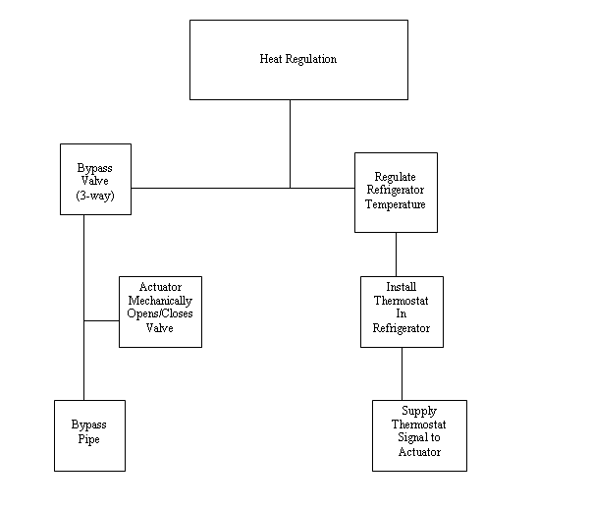

Water Management
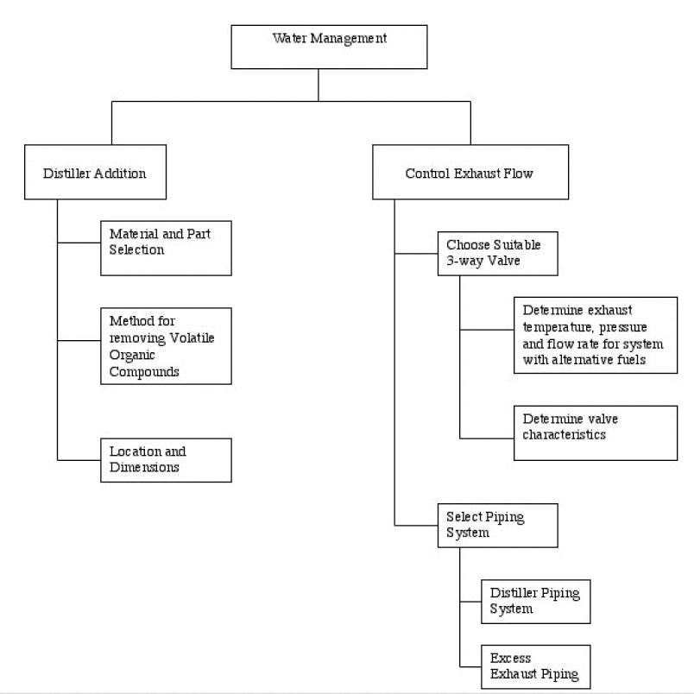

Alternative Fuel

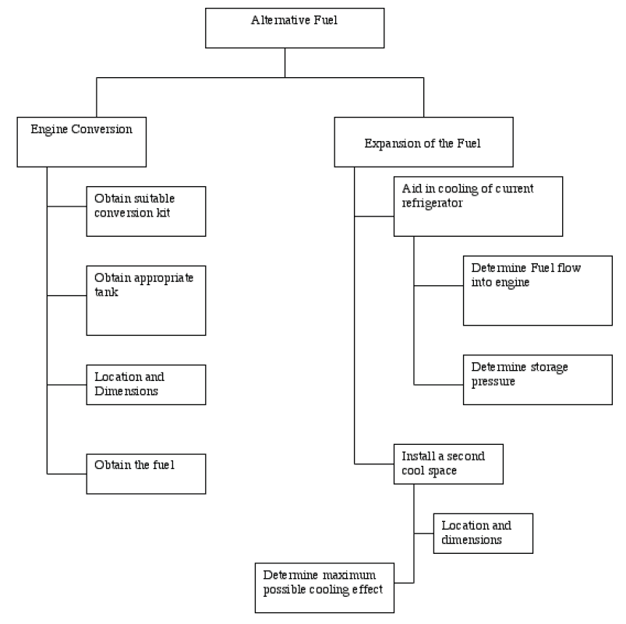

Expansion Effects

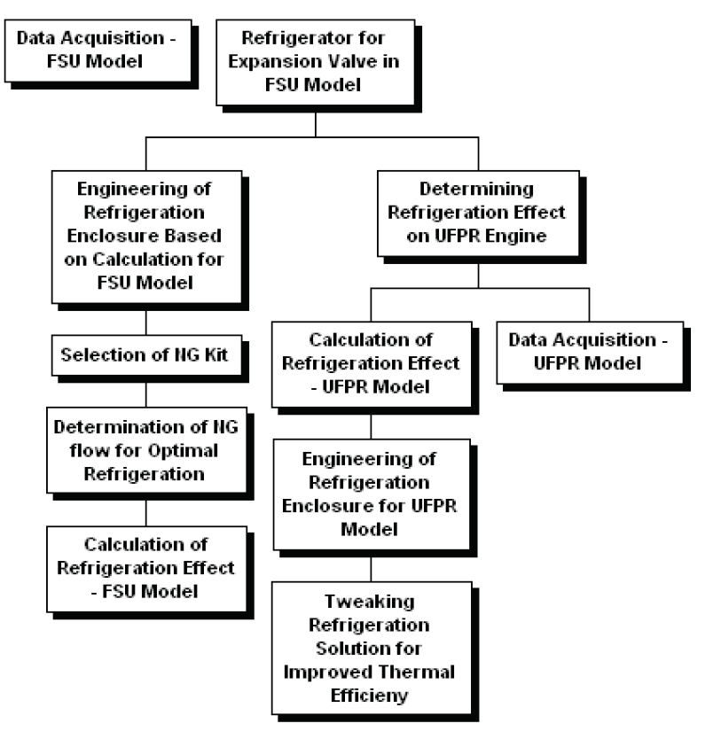

Appendix C: Conceptual Designs Drawings and Schematics

Appendix C-1: Heat Bypass Design and Schematics

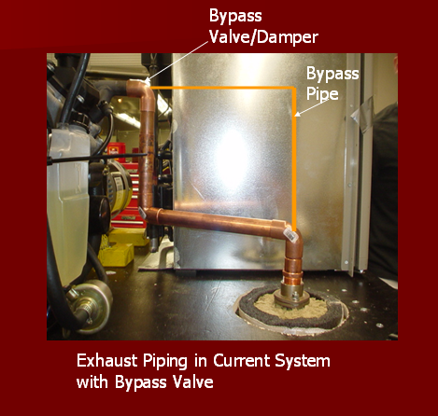

Butterfly Valve/Damper

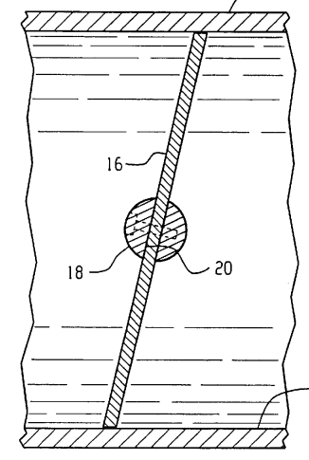
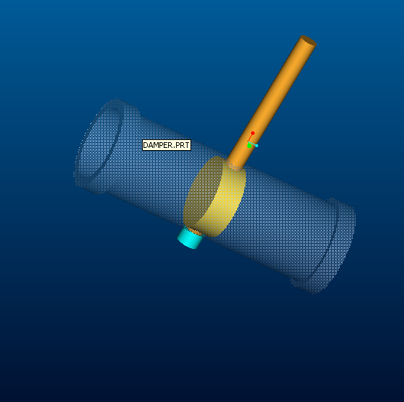

Damper Assembly for a 1” Copper Pipe.

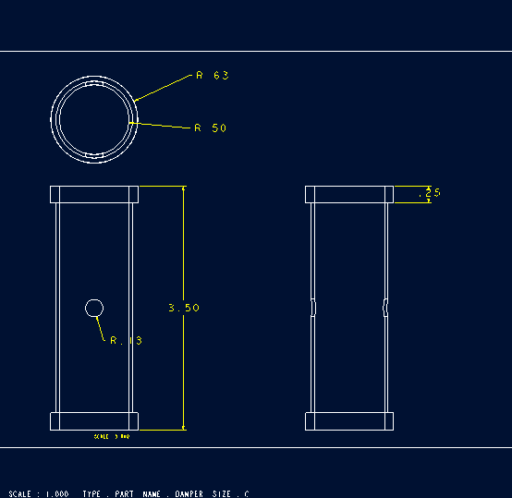
Damper Housing

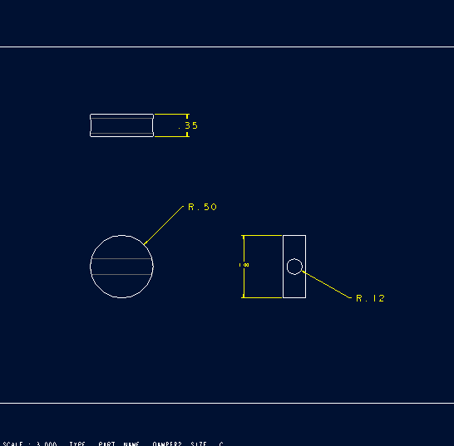
Damper/Butterfly Valve

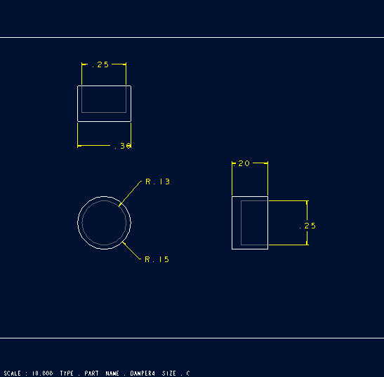
Shaft Cap

Rotary Actuator

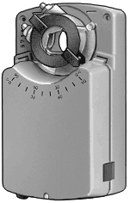

Use to position and control air dampers. Actuators are adjustable for clockwise and counterclockwise rotation from 0° to 90° (unless noted). No linkages required—they directly operate the damper shaft. UL listed and CSA certified.
Incremental input signal activates when the system varies from the setpoint by a certain amount. Actuator is moved to a new position only until the system requirement is met and then stops. Requires 24 VAC at 50/60 Hz or 24 VDC except, K17, and K24, which operate on 24 VAC, 50/60 Hz only.
Proportional input signal provides the best control since the actuator is constantly being positioned in response to system requirements. Requires 0 to 10 VDC or 0 to 20 mA. Actuators with spring return can be set to return the damper from either direction and have a manual crank for precise adjustment.

Appendix D: Supporting Calculations

Appendix D-1: Distiller Supporting Calculations

For the water distiller chosen, it is desired to determine how much energy is needed to vaporize 3 liters of water.

P = 101.5 kPa
m_{water}= 3 kg
h_{fg}= 2258kJ/kg (Latent Heat of Vaporization)

The amount of energy needed:
$$E={\text{mh}}_{\text{fg}}=3\text{kg}·\text{2258}\text{kJ}\text{kg}=\text{6774}\text{kJ}$$

Appendix D-2: Adapted Engine Theoretical Performance Calculations

Units

Appendix E: Vendors

- Waterwise Inc. (Non-electric Water Distiller)
- McMaster-Carr, www.mcmaster.com, Rotary Actuator
- Carburetion and Turbo Systems, www.carbturbo.com, Engine Adapter
4. Scuba Toys, www.scubatoys.com, Fuel Tank

Appendix F: Cost Analysis

 | Component | Sub-Component | Qty | Description | Unit Price | Price
Engine Conversion
 | Conversion Kit |  | 1 | Model # 720-FD501-5 | $243.75
 | Fuel Tank |  | 3 | Model # X8-130 | $389.95 | $1,169.85
Water-Heating Unit | Water Distiller |  | 1 | Model 1600 | $369.00 | $369.00
Piping System |  |  |  | Piping, insulation, valves | $325.00 | $325.00
 | Rotary Actuator |  | 1 | Rotary Actuator | $292.00 | $292.00

